**Moving Terps Project Plan**

Team: Section 3 Group 4

Team Members: Krishik Nataraj Gowda, Tanmay Bagdiya, Sameep Sheth, Raghul Pandi, Kai-Hsiang Lin, Jingru Liu, Ziqi Han, Yi-Ching Lin

Client: The Department of Transportation Services (DOTS), The University of Maryland, College Park (UMD)

**Executive Summary** **1**

**Introduction** **2**

**System Planning Phase Report** **2**

1.0 Introduction of the client 2

1.1 Opportunity 2

1.2 Project Objective 3

1.3 Project Scope 3

2.0 Project Methodology 4

2.1 Justification 4

3.0 Project Plan 4

**System Analysis Phase Report** **6**

4.0 Requirements 6

4.1 Business requirements 6

4.2 User requirements 6

4.3 Functional requirements 7

Process 7

Information 7

4.4 Non-functional requirements 8

Operational 8

Performance 8

Security 8

Cultural and political 8

5.0 Data Flow Diagrams 8

5.1 Context Diagram 8

5.2 Level 0 Diagram 10

5.3 Level 1 Process Tables 11

5.3.1 Account Management 11

5.3.2 Parking Service 11

5.3.3 Shuttle Bus Service 12

5.3.4 Notification 13

5.3.5 Third-party online payment system 13

5.3.6 Add to User Favorite 13

5.4 Entity Relationship Diagram 14

5.5 Swimlane Processes Diagrams 15

5.5.1 Account Management System 15

5.5.2 Parking Service 15

Parking Lot and Route Searching 15

Vehicle Information 16

Permit Purchase 16

Citation Payment 16

5.5.3 Shuttle Bus Service 16

Search a Route 16

Near-by Stations 17

Route Planning 17

Track your ride 18

5.5.4 Notification 18

5.5.5 Online Payment System 18

5.5.6 Add to User Favorites 19

**System Designing Phase** **20**

6.0 Physical ERD 20

7.0 User Interface 20

8.0 System Design Architecture 22

9.0 Testing Plan/Documentation 23

9.1 Stub testing 23

9.2 Unit testing 23

9.3 System testing 25

9.4 Acceptance testing 25

9.5 Integration testing 25

10.0 Implementation Plan 25

10.1 Objectives 25

10.2 Details and Deliverables 25

10.3 Implementation Plan Schedule 26

11.0 Conclusion 27

## Executive Summary

*Moving Terps* is the proposed mobile application outlined in this proposal. It is aimed to serve as the integration of the current Next Bus shuttle service mobile application and the parking portal offered by the Department of Transportation Services (DOTS) of the University of Maryland, College Park (UMD.) The five major modules of this application will be account management, parking service, shuttle bus service, add to favorites, and notification. The application will also be integrated with third-party online payment systems that allows users to pay for parking permits and citations and a mobile identity verification system that enables users to read shuttle bus information and store ride history information.

The team will be using a waterfall and prototype mixed methodology due to the fact that the service provided by DOTS is relatively static; thus, the requirements of the application are well-defined which can be fulfilled in phases. In addition, since we are trying to replace the legacy application and website provided by DOTS, it is crucial to collect feedback from students and faculties so the team can identify changes and refine before the final implementation. All components of this mobile application will be tested before implementation.

## Introduction

This project aims to integrate transportation services provided by the Department of Transportation Services (DOTS) of the University of Maryland, College Park (UMD) and develop a comprehensive mobile application, *Moving Terps*. It will serve as the main tool for assisting students, faculty, and staff to commute to and travel around the campus.

## System Planning Phase Report

### 1.0 Introduction of the client

The Department of Transport Services (DOTS) is an integral part of University of Maryland (UMD). DOTS is committed to providing safe, cost effective and innovative services that anticipate the needs of our growing community of more than 50,000 students, faculty and staff in the city of College Park and beyond.

The various services provided by DOTS include a free shuttle program for its users, an on- demand NITE ride facility for users living in the vicinity of the campus, Charter for long haul travel, parking system in the university, and sustainable transport facilities like carpool, carshare, electric vehicle charging stations.

#### 1.1 Opportunities

The main goal of a university transportation department is to provide cost effective and hassle free transportation to its users. DOTS UMD has many such facilities to achieve this goal but the main problem that it faces is that this information is spread around multiple applications and websites with no single repository of information which makes it difficult for users to take advantage of this facility.

So this project gives us an opportunity to integrate all the functions and facilities provided by DOTS into a single mobile application. We also aim to make these facilities more interactive and user friendly for all users by adding new functionalities in the application for shuttle service and for parking.

#### 1.2 Project Objectives

The main objective of the project is to present UMD students, faculties, and staff with a transportation service mobile application that is easy to use. It will not only make up for the deficiencies of the current system, but it will also increase the user satisfaction rate by enhancing the user experience. Therefore, it is time for our app, *Moving Terps*, to come to offer by truly connecting with our users and understanding their needs and constraints.

#### 1.3 Project Scope

*Moving Terps* is a mobile application which aims to make daily commute and parking facility around the campus more convenient and efficient. The app transforms the most frequently used services provided by the UMD Department of Transportation Services into functions on the interface for easier access. Enrolled students, faculty, and staff will have access to the application by logging into their directory id. As a user-based instead of office-based system, *Moving Terps* display transportation information in a more dynamic and smart way by allowing users to interact with the application and receive recommendations. The deployment of *Moving Terps* should increase users’ satisfaction rate and provide much more intuitive and accurate transportation information.

Functions

1. Accounts: users will be able to log into the application with UMD directory id. The system should be able to identify account types (student/staff/faculty.)
2. Shuttle: users are able to enter starting location and destination, and the application will recommend bus routes along with real-time bus tracking information (location, arriving time and capacity) on an interactive map. Users can also check nearby stations and the routes passing by.
3. Parking: users are able to enter starting location and destination, and an interactive map will show parking lot recommendations based on user type together with the detailed parking lot restrictions. Then, by clicking on a recommended parking lot, the system will show the direction to get to that selected parking lot. Additional features under this function include: update personal and vehicle information, pay for permits, citations, and temporary parking, appeal against citations
4. Notification: Notify any impact schedule and current status (specific shuttle and parking lot availability during special events) through “push notification.” Users don’t need to check email or the impact calendar manually.
5. User Favorites: users are able to add their frequently-used bus routes, bus stops, and parking lots as their favorite items.

Integrations

1. Third-party online payment system to allow students to pay for parking permits, citations, and temporary parking.
2. Mobile identity verification system to allow users utilize mobile devices to scan QR code/tap on a NFC (near-field communication) terminal so that their identity can be verified and the trip information can be stored in their accounts. A NFC terminal will need to be installed on each bus.

### 2.0 Project Methodology

#### 2.1 Justification

Of the various system development methods, a hybrid of waterfall and system prototyping best fits our goal.

This project has well defined requirements that don't change substantially during the development cycle. Additionally, there is privilege of time as most of the services, although not integrated and easy to use, are available across applications and DOTs website. Finally, incorporating system prototype in the design phase, allows for feedback cycles from users to identify changes and refine real requirements before implementation.

### 3.0 Project Plan

|  |  |  |  |  |
| --- | --- | --- | --- | --- |
| **WBS** | **NAME** | **Duration** | **Start**  **Date** | **End date** |
| **1** | **Project** | 187 | 2/9/22 | 8/19/22 |
| **1.1** | **Initiation** | 31 | 2/9/22 | 3/12/22 |
| 1.1.1 | Preliminary plan | 10 | 2/10/22 | 2/20/22 |
| 1.1.2 | Detailed project plan | 10 | 2/20/22 | 3/2/22 |
| 1.1.3 | Objective identification | 10 | 3/2/22 | 3/12/22 |
| 1.1.4 | Plan finalization | 1 | 3/12/22 | 3/12/22 |
| **1.2** | **Analysis and Interviews** | 35 | 3/13/22 | 4/17/22 |
| 1.2.1 | Collect requirement from students | 10 | 3/13/22 | 3/23/22 |
| 1.2.2 | Collect requirement from faculty | 10 | 3/23/22 | 4/2/22 |
| 1.2.3 | Collect requirement from transportation office | 10 | 4/2/22 | 4/12/22 |
| 1.2.4 | Requirement Determination | 5 | 4/12/22 | 4/17/22 |
| **1.3** | **Design** | 65 | 4/18/22 | 6/22/22 |
| 1.3.1 | Design plan brainstorm | 10 | 4/18/22 | 4/28/22 |
| 1.3.2 | Prototype | 20 | 4/29/22 | 5/9/22 |
| 1.3.3 | Database design | 10 | 5/10/22 | 5/19/22 |
| 1.3.4 | Interface design | 10 | 5/20/22 | 5/29/22 |
| 1.3.5 | Back-End design | 10 | 5/30/22 | 6/9/22 |
| 1.3.6 | Documentation | 5 | 6/10/22 | 6/22/22 |
| **1.4** | **Implementation** | 39 | 6/23/22 | 8/1/22 |
| 1.4.1 | Evaluate design plan | 5 | 6/23/22 | 6/27/22 |
| 1.4.2 | Unit implementation | 20 | 6/28/22 | 6/18/22 |
| 1.4.3 | Acquire system access | 2 | 6/19/22 | 6/20/22 |
| 1.4.4 | Integrated with different systems | 10 | 6/21/22 | 6/30/22 |
| 1.4.5 | Documentation | 2 | 6/30/22 | 8/1/22 |
| **1.5** | **Test** | 17 | 8/2/22 | 8/19/22 |
| 1.5.1 | Function Test | 5 | 8/2/22 | 8/6/22 |
| 1.5.2 | Requirement Check | 5 | 8/7/22 | 8/11/22 |
| 1.5.3 | User Feedback Analysis | 5 | 8/12/22 | 8/16/22 |
| 1.4.4 | Documentation | 2 | 8/17/22 | 8/19/22 |

## System Analysis Phase Report

### 4.0 Requirements

#### 4.1 Business requirements

* Must be a mobile application
* Provide search capabilities for shuttle bus and parking service
* Show optimized search results in an interactive map
* Provide push notification and offer options for signing up
* Integrate with third-party online payment systems
* Capture and store ride information with NFC technology

#### 4.2 User requirements

* Users will be able create an account and login with UMD Directory ID
* Users will be able to update personal information
* Users will be able to sign up for push notifications
* Users will be able to check selected favorite bus routes, stops, and parking lots
* Shuttle Service:
  + Users will be able to search for a specific bus routes
  + Users will be able to search for near-by bus stations
  + Users will be able to enter starting and ending locations to plan for a route
  + Users will be able to save frequently-used bus routes and stops as favorites
  + Users will be able to record ride history by tapping their mobile device on the NFC terminals on the buses
  + Users will be able to review ride history
* Parking Service:
  + Users will be able to search for available parking lots and areas based on input data (user type, arrival time of day, starting location, and destination)
  + Users will be able to add and update vehicle information
  + Users will be able to pay for parking permits and citations
  + Users will be able to search and appeal against citations
  + Users will be able to save frequently-used parking lots as favorites

#### 4.3 Functional requirements

##### Process

* + Software should allow users to search for specific bus routes and display route number & name, traveling direction, starting/terminal stops, all stops of that route, and operational status (running/offline, current location) in an interactive map
  + Software should display search results based on user location in an interactive map
  + Software should allow users enter starting/ending locations and departure/arrival by time, and the software must display optimized route by shortest travel time in an interactive map
  + Software should add the selected bus routes or stops and selected parking lots into the “UserFavorite” database
  + Software must automatically estimate the arrival time of each bus at the next stop
  + Software should allow users to search for available parking lots and areas with search filter inputs (user type, arrival time of day, destination) and display search results in an interactive map
  + Software should display detailed information about parking lots when users click on each available parking lots
  + Software should generate an optimized route from the user’s location to the selected parking lot when user click on “direction” in each available parking lot
  + Software should allow users to add and update vehicle information
  + Software should allow users to pay for parking permits and citations
  + Software should allow users to search for parking permits and citation history
  + Software should allow users to review and write appeals on citations
  + Software should allow users to sign up for notifications
  + Software should allow users to edit personal information
  + Software must capture and store ride information into ride history database when users tap their mobile devices on a NFC terminal
  + Software should allow users to review ride history

##### Information

* + Software must store all user accounts information
  + Software must capture all bus routes, bus stops, and ride schedule data
  + Software must capture location information of all operating buses
  + Software must store all detailed information about parking lots, parking restrictions, and impact schedule
  + Software must store routes, bus stops, and parking lots marked as favorites by users
  + Software must have an interactive map that display all data about parking lots and spaces, shuttle bus stops, and optimized routes
  + Software must store ride history
  + Software must capture user information
  + Software must store information about purchased permits, vehicle, and citations
  + Software must store citation appeal letters posted by users
  + Software must store comments of appeal letters posted by system administrators

#### 4.4 Non-functional requirements

##### Operational

* + The software will run on IOS and Android devices
  + The software should integrate with third-party payment systems
  + The software should enable NFC technology to be able to read and write information from a NFC terminal on the buses

##### Performance

* + Any interaction between the user and the system should not exceed 2 seconds
  + The software should update real-time bus location and arrival times every 30 seconds
  + The software should be available for use for 24 hours per day, 365 days per year.
  + The software should support 5000 simultaneous users from 8-11 am and 3-7 pm; 3000 simultaneous users at all other times

##### Security

* + Only people with active UMD Directory ID can register for an account
  + Users should log into the system with UMD Directory ID
  + System administrators will have access to update shuttle bus service and parking service information
  + System should not store user credit/debit card information
  + Personal information should not be shared with third-party systems
  + The system should include all available safeguards from malware

##### Cultural and political

* + System should ask consent from users for push notifications
  + Personal information should be protected in compliance with the Data Protection Act

### 5.0 Data Flow Diagrams

#### 5.1 Context Diagram

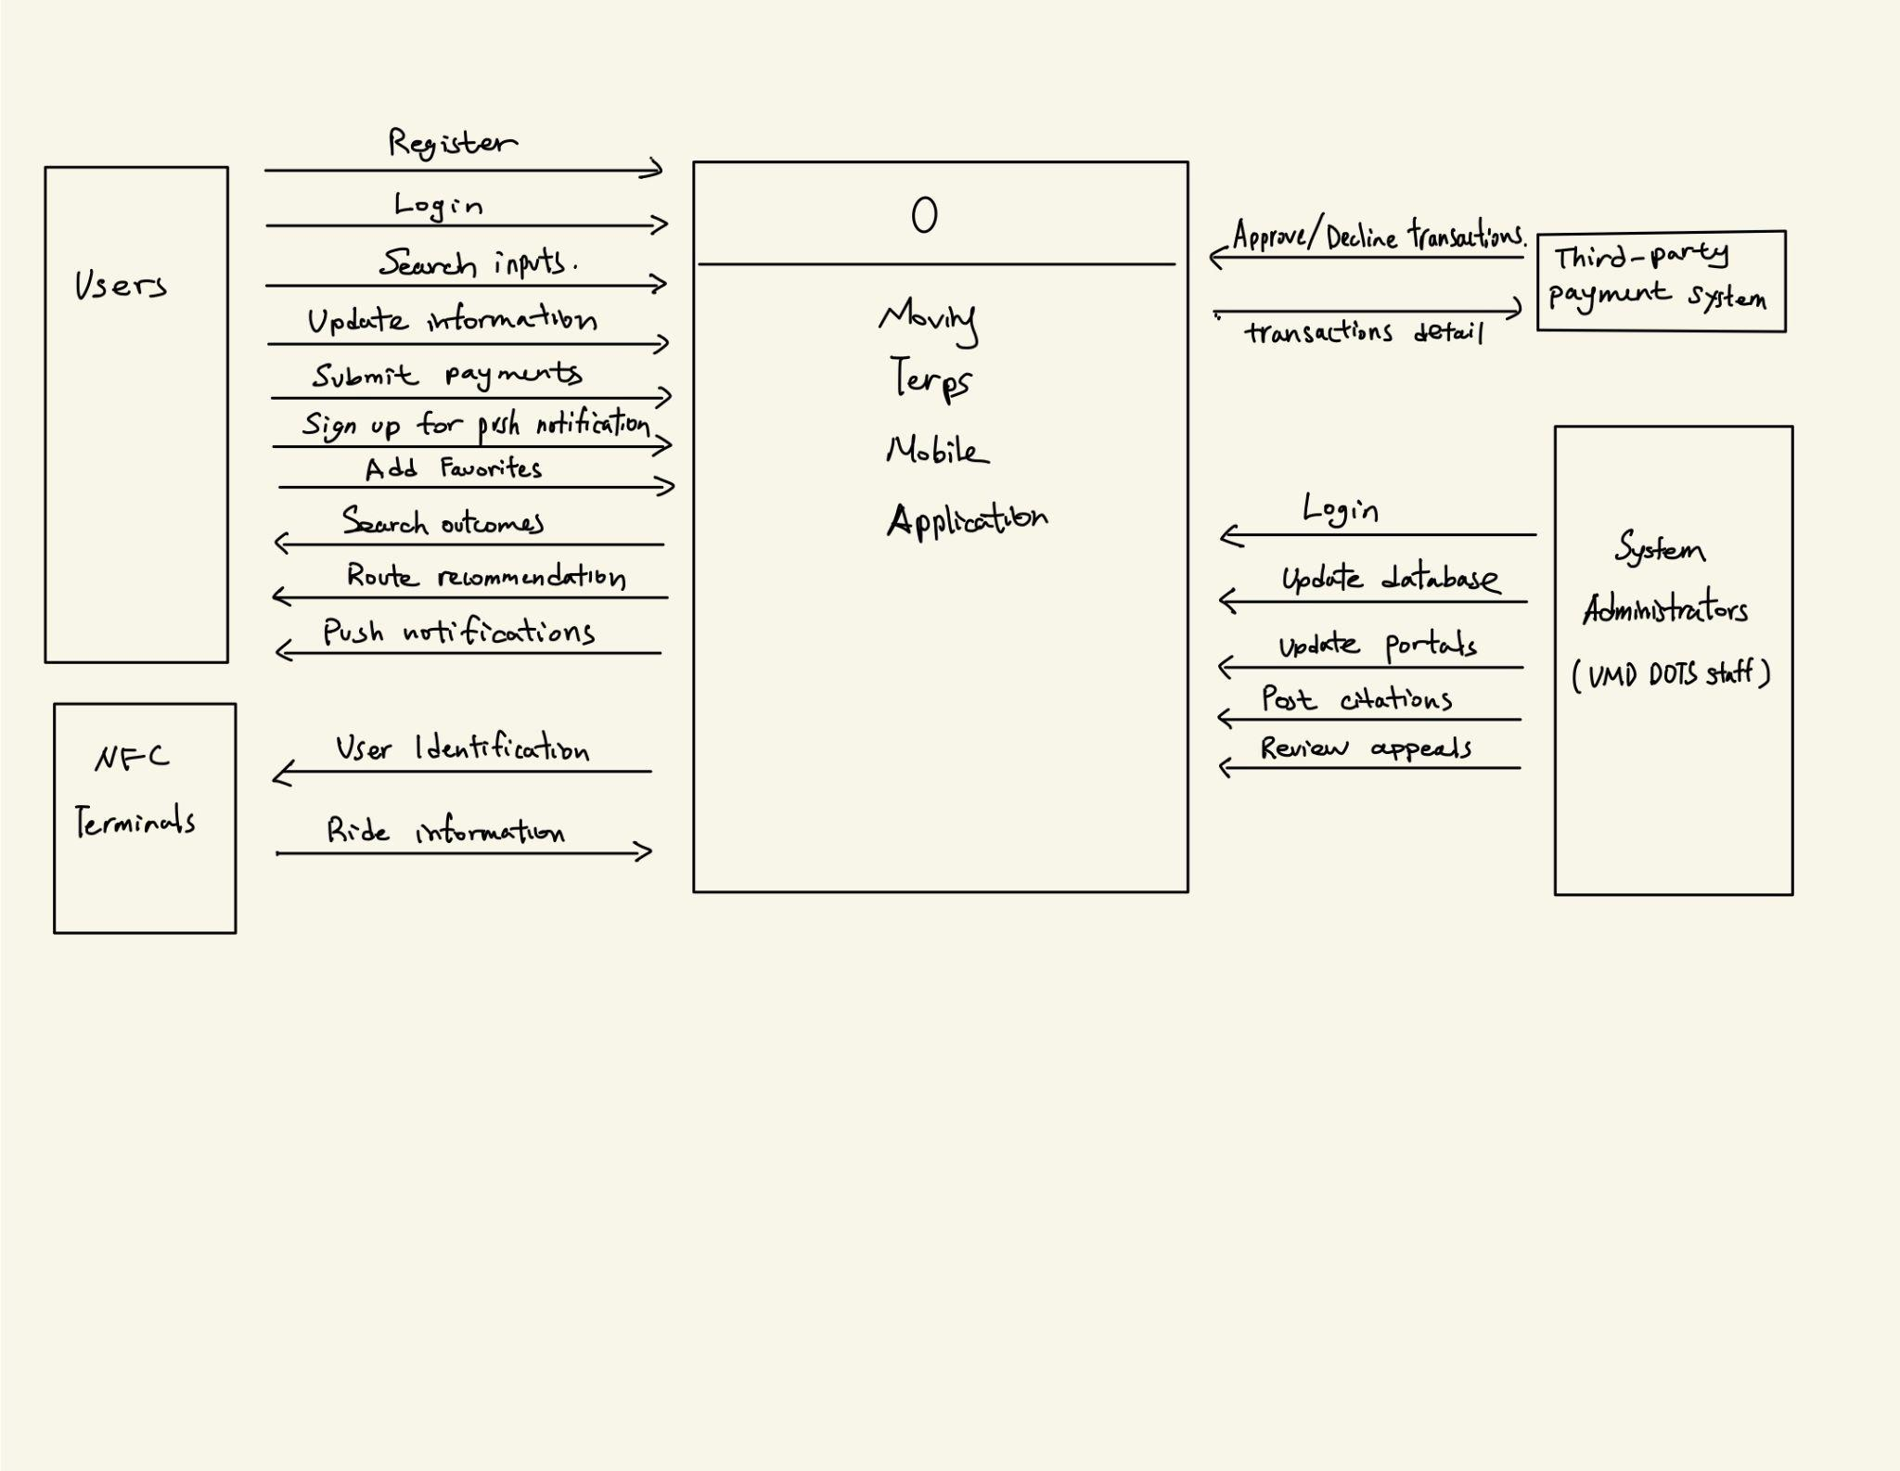

External Entities:

* **Users**: represent the active/current UMD students and faculty & staff
* **System Administrators**: represent authorized UMD Department of Transportation Service (DOTS) staff that have access to the datastores
* **Third-party Payment System**: represents the system that gives the Moving Terps mobile application the ability of making transactions without check or cash
* **NFC Terminal**: represents the machines install on the UMD shuttle buses that read user information and send ride information to user accounts

System Inputs:

*From Users*

* Account information
* Search inputs
* Edit/update information
* Submit payments
* Sign up for push notifications
* Add to Favorites

*From System Administrators*

* Account information
* Add/update databases
* Update portals
* Post citations
* Review appeal letters

*From Third-party Payment System:*

* Approve/decline transactions

*From NFC Terminal*

* Ride information

System Outputs:

*To Users*

* Search outcomes
* Route recommendations
* Push notifications

*To Third-party Payment System*

* Transaction detail

*To NFC Terminal*

* Ride information

#### 

#### 

#### 

#### 5.2 Level 0 Diagram

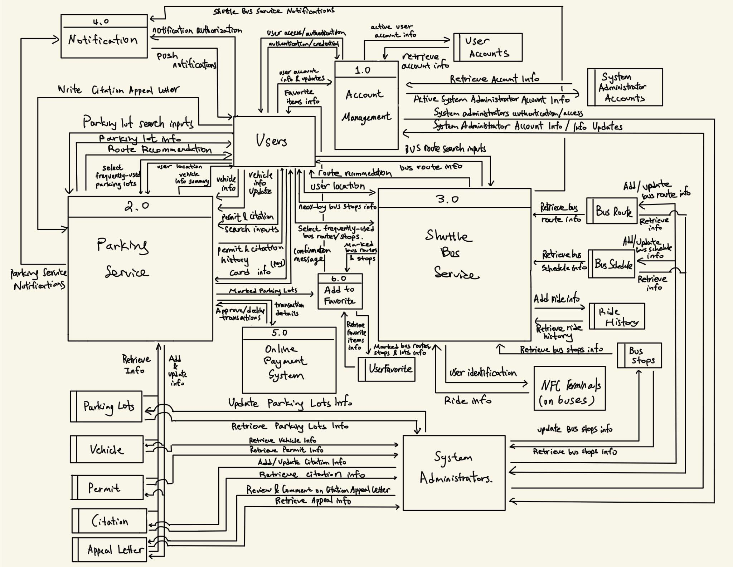

#### 5.3 Level 1 Process Tables

##### 5.3.1 Account Management

|  |  |
| --- | --- |
| Inputs | Outputs |
| From Users:   1. Account information (UID, password, name, user type, address, phone number, email address) 2. Authentication/credential - password | To Users:   1. User authentication/access |
| From User Accounts datastore:   1. Retrieve active user account information | To User Accounts datastore:   1. Active user account information |
| From System Administrators:   1. Account information (UID, password, name, phone number, email address) | To System Administrators:   1. System administrators authentication/access |
| From System Administrator Accounts datastore:   1. Retrieve active system administrator account information | To System Administrator Accounts datastore:   1. Active system administrator account information |

##### 5.3.2 Parking Service

|  |  |
| --- | --- |
| Inputs | Outputs |
| i) Parking Map  From User:   1. Parking lot search 2. Frequently-used parking lot 3. User location   From Parking Lot datastore:   1. Retrieve parking lots information | To Users:   1. Parking lot information 2. Route recommendation 3. Marked parking lot |
| ii) Vehicle  From User:   1. Vehicle information updated 2. Vehicle information added   From Vehicle datastore:   1. Retrieve vehicle information | To Users:   1. Vehicle information summary   To Vehicle datastore:   1. Add/update vehicle information |
| iii) Permit From Users:   1. Permit search inputs 2. Card information   From Permit datastore:   1. Retrieve permit information   From Online Payment System:   1. Approve/Decline transaction | To Users:   1. Permit history 2. Purchase confirmation message   To Permit datastore:   1. Add/update permit information   To Online Payment System:   1. Transaction details |
| iv) Citation From Users:   1. Citation appeal letter 2. Citation search inputs 3. Card information   From Citation datastore:   1. Retrieve citation information   From Appeal Letter datastore:   1. Retrieve appeal letter information   From Online Payment System:   1. Transaction approval/decline | To Users:   1. Citation history 2. Payment confirmation message   To Appeal Letter datastore:   1. Add/update appeal letter information   To Online Payment System:   1. Transaction details |

##### 5.3.3 Shuttle Bus Service

|  |  |
| --- | --- |
| Inputs | Outputs |
| i) Search a Route  From User:   1. Search input 2. Select frequently-used bus routes and stops   From Bus Route datastore:   1. Routes detail   From Bus Schedule datastore:   1. Schedule detail   From Bus Stops datastore:   1. Stops detail | To User:   1. Routes, stops, and schedule detail   To Shuttle Bus Service function:   1. Marked bus routes and stops |
| ii) Near-by Stations  From User:   1. User location 2. Select frequently-used bus routes and stops   From Bus Route datastore:   1. Routes detail   From Bus Schedule datastore:   1. Schedule detail   From Bus Stops datastore:   1. Stops detail | To User:   1. Nearby bus stops detail   To Shuttle Bus Service function:   1. Marked bus routes and stops |
| iii) Route Planning  From User:   1. Starting location 2. Destination Location 3. Departure time / Arrival by time   From Bus Route datastore:   1. Routes detail   From Bus Schedule datastore:   1. Schedule detail   From Bus Stops datastore:   1. Stops detail | To User:   1. Available route options sorted by shortest time 2. Nearest route stop from the user starting location and distance 3. Bus arrival time at nearby stops. |
| iv) Track Your Ride  From User:   1. User identification (user information) | To User:   1. Ride history information and tracking (from NFC terminals on buses) |

##### 5.3.4 Notification

|  |  |
| --- | --- |
| Inputs | Outputs |
| From Users:   1. Notification preference authorization selection/update   From Parking Service Function:   1. Parking Information according to preference setting   From Shuttle Bus Service function:   1. Shuttle Bus Information according to preference setting | To Users:   1. Push notifications |

##### 5.3.5 Third-party online payment system

|  |  |
| --- | --- |
| Inputs | Outputs |
| From Parking Service function:   1. Transaction details | To Parking Service function:   1. Transaction approval/decline |

##### 5.3.6 Add to User Favorite

|  |  |
| --- | --- |
| Inputs | Outputs |
| From Parking Service function:   1. Marked parking lots | To User Favorite datastore:   1. Marked parking lots information |
| From Shuttle Bus Service function:   1. Marked bus routes and stops | To User Favorite datastore:   1. Marked bus routes and stops information |
| From User Favorite datastore:   1. Retrieve favorite items information | To Users:   1. Favorite items information |

### 6.0 Swimlane Processes Diagrams

#### 6.1 Account Management System

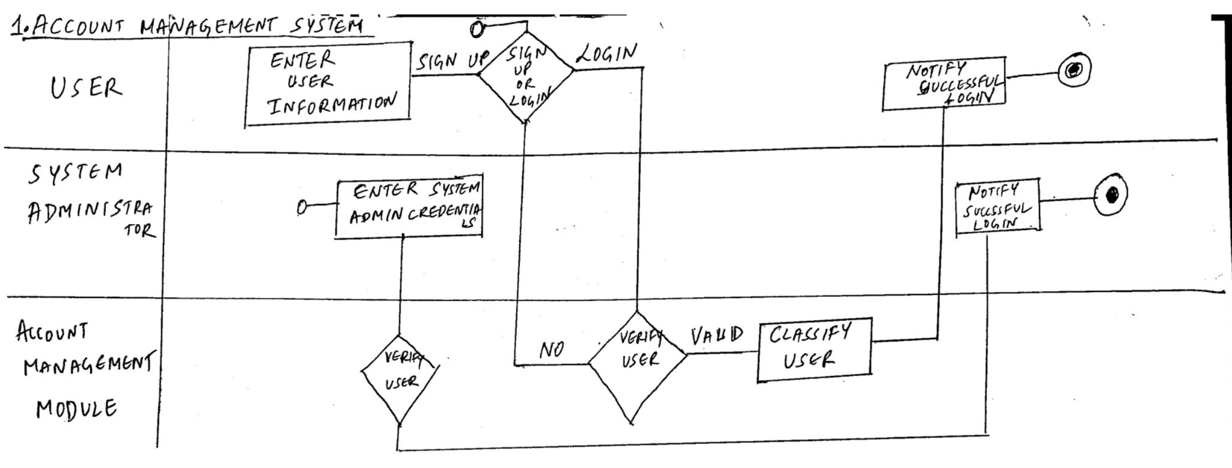

#### 6.2 Parking Service

##### Parking Lot and Route Searching

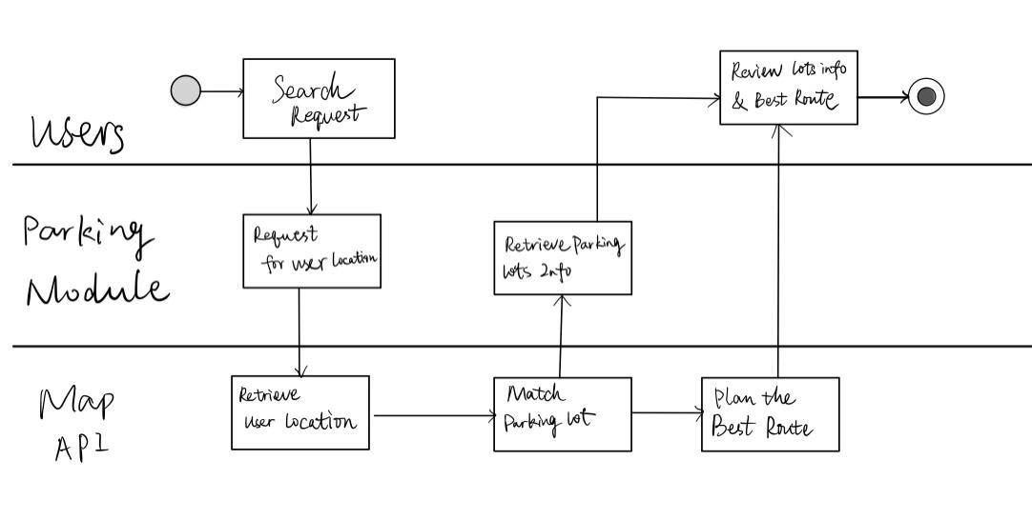

##### Vehicle Information

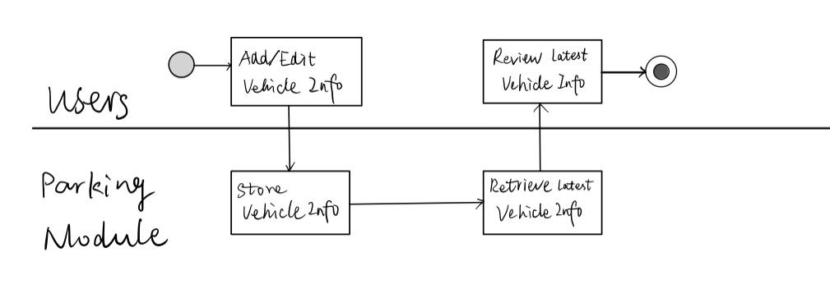

##### Permit Purchase

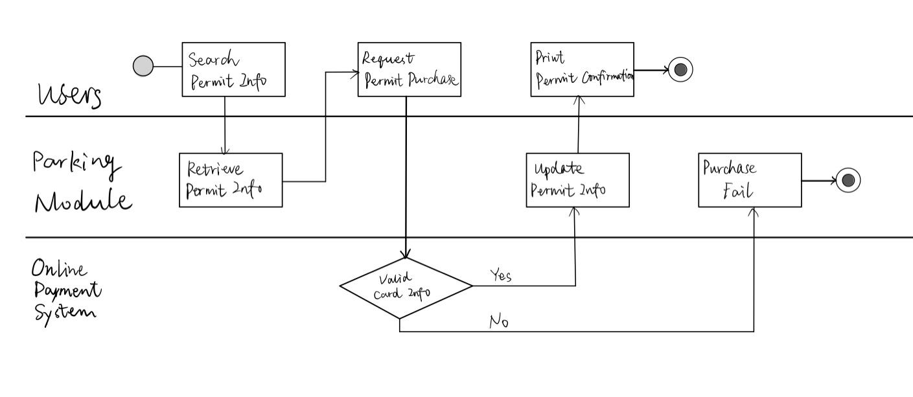

##### Citation Payment

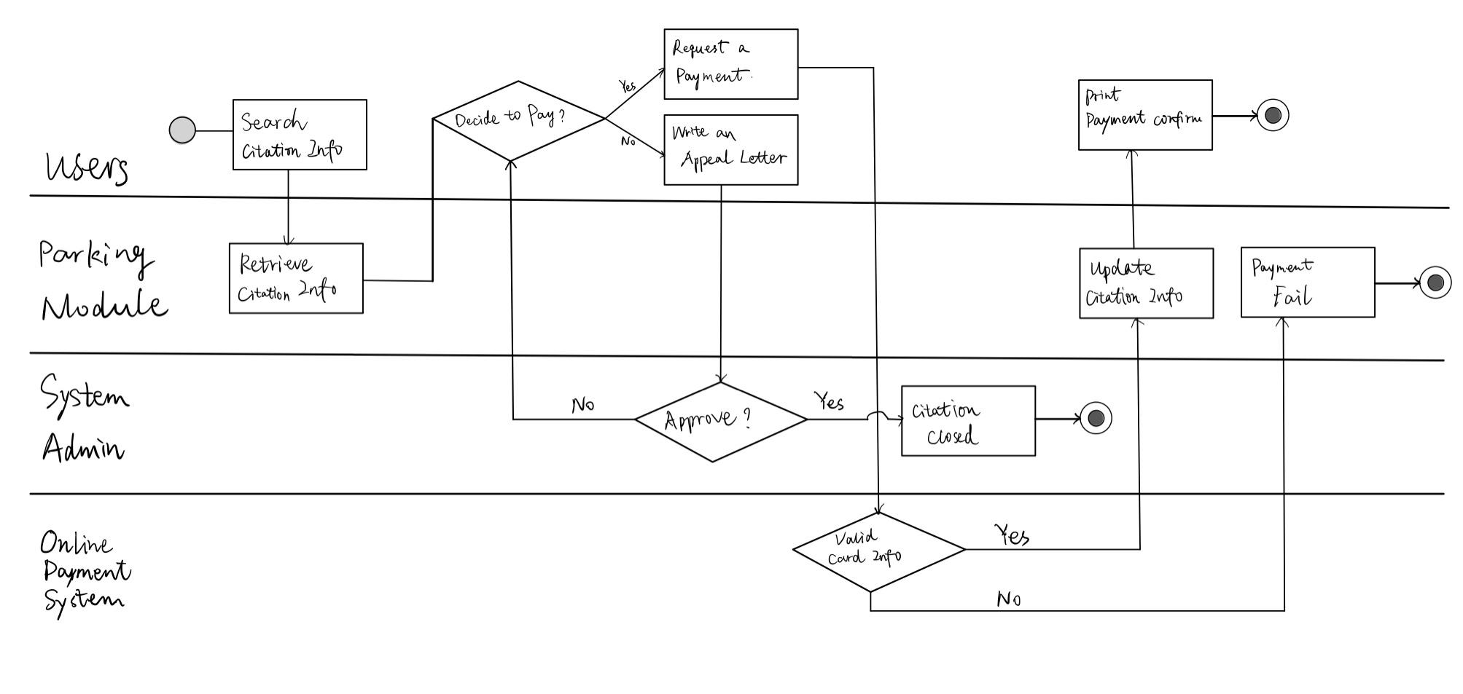

#### 6.3 Shuttle Bus Service

##### Search a Route

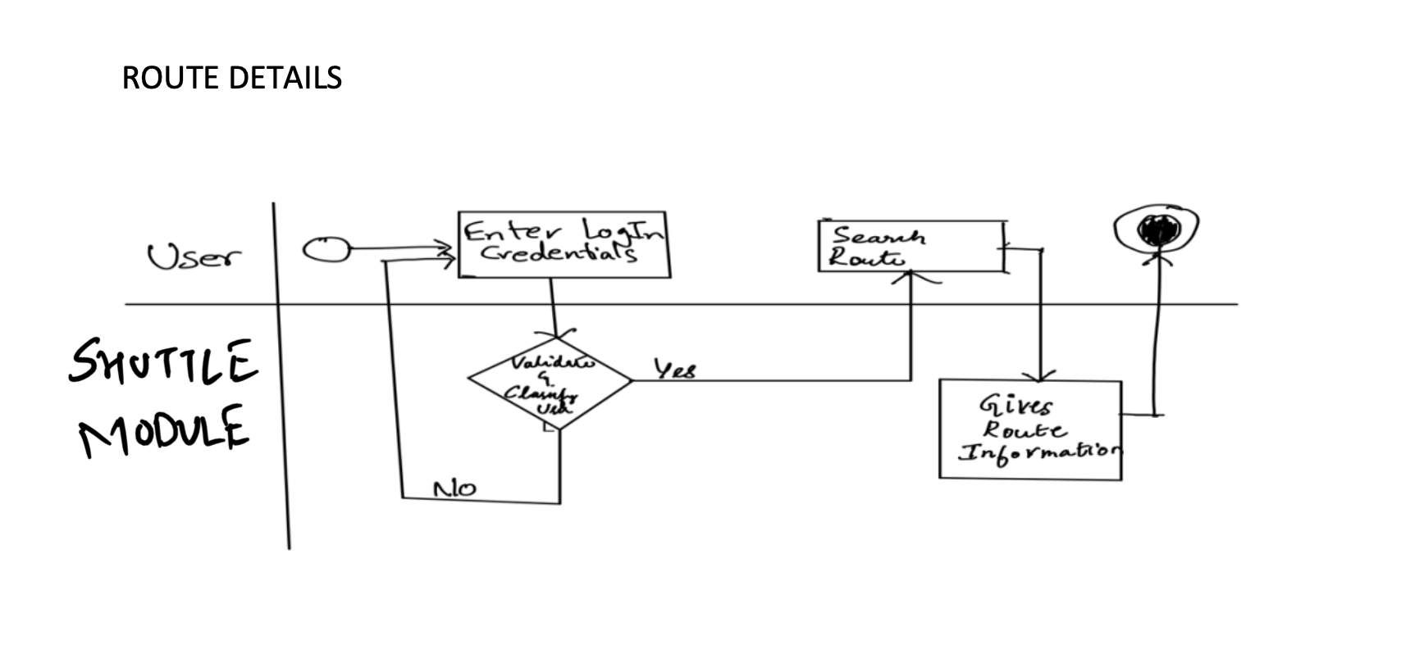

##### Near-by Stations

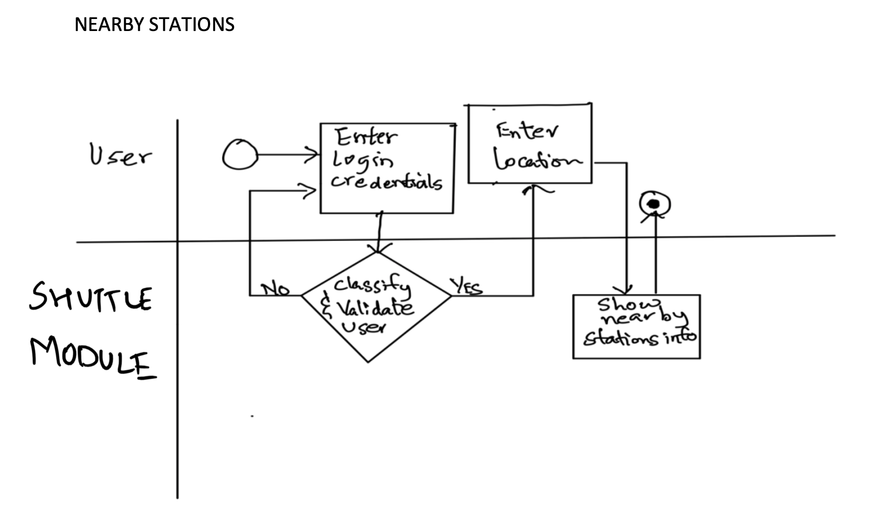

##### Route Planning

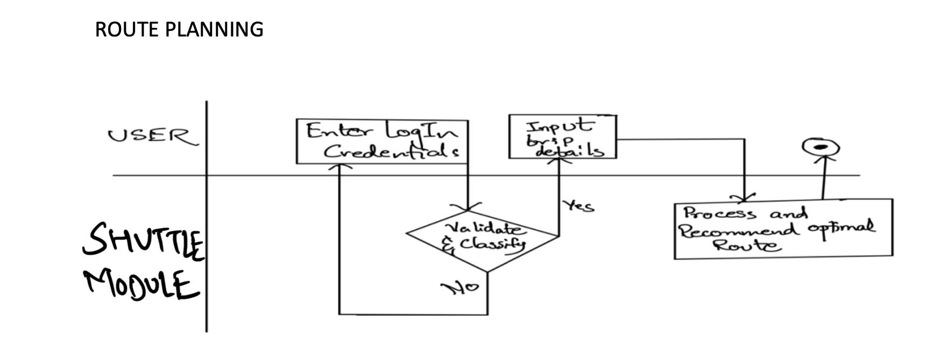

##### Track Your Ride

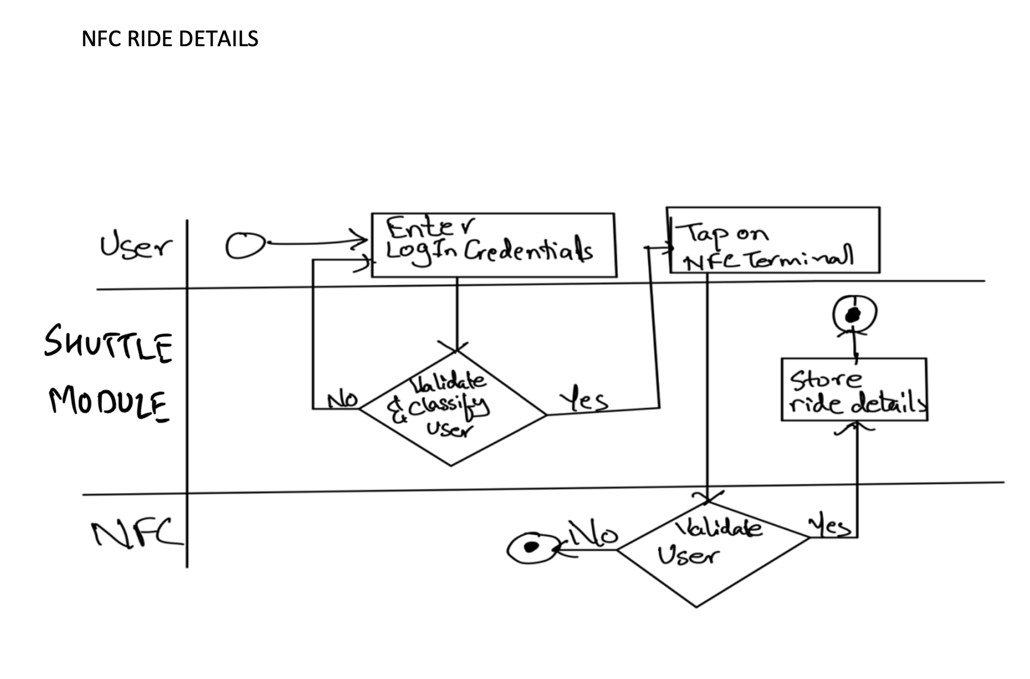

#### 6.4 Notification

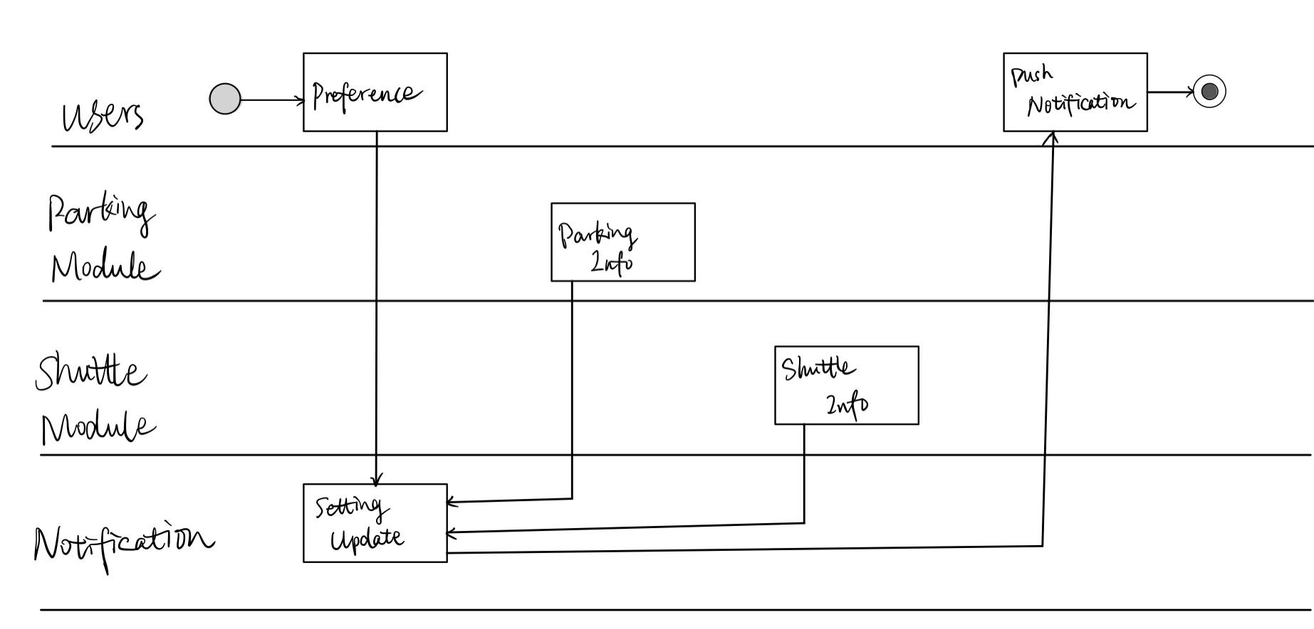

#### 6.5 Online Payment System

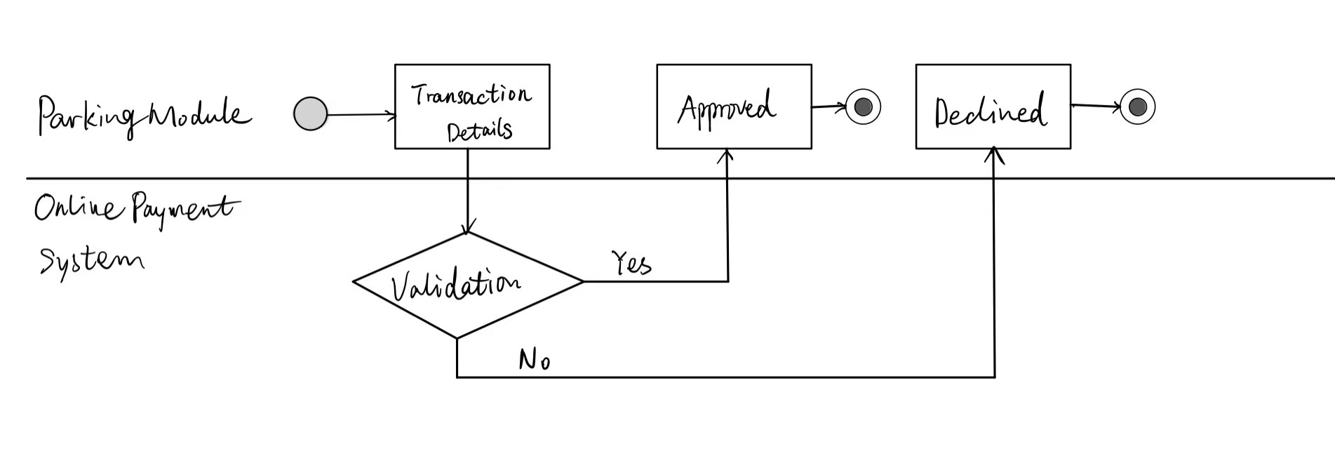

#### 6.6 Add to User Favorites

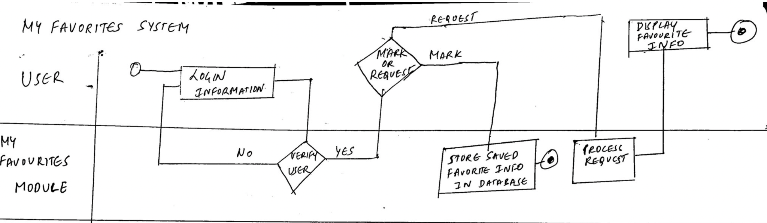

## System Designing Phase

### 7.0 Physical ERD

### 

### 8.0 User Interface

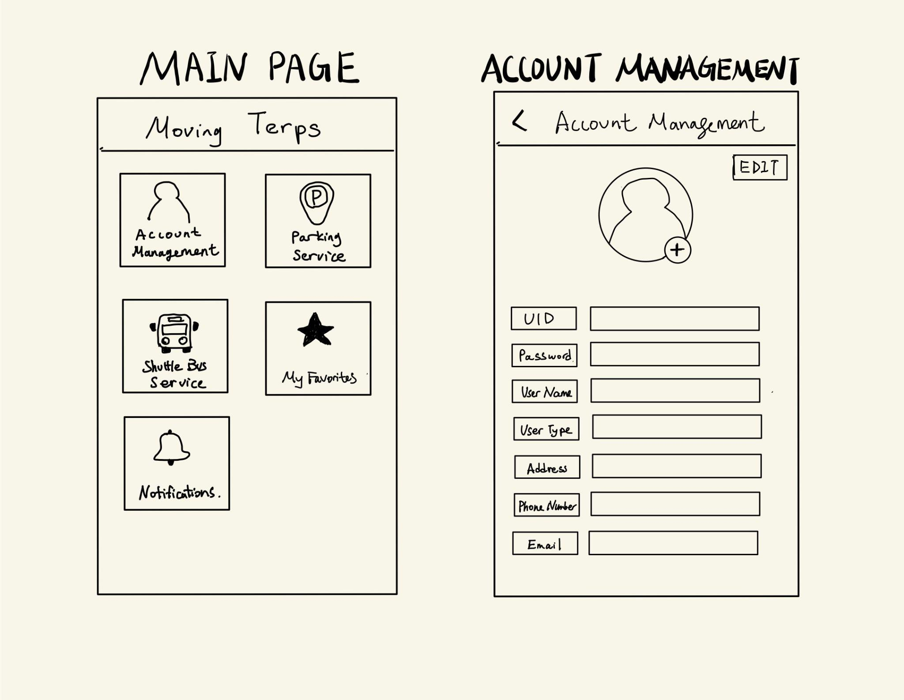

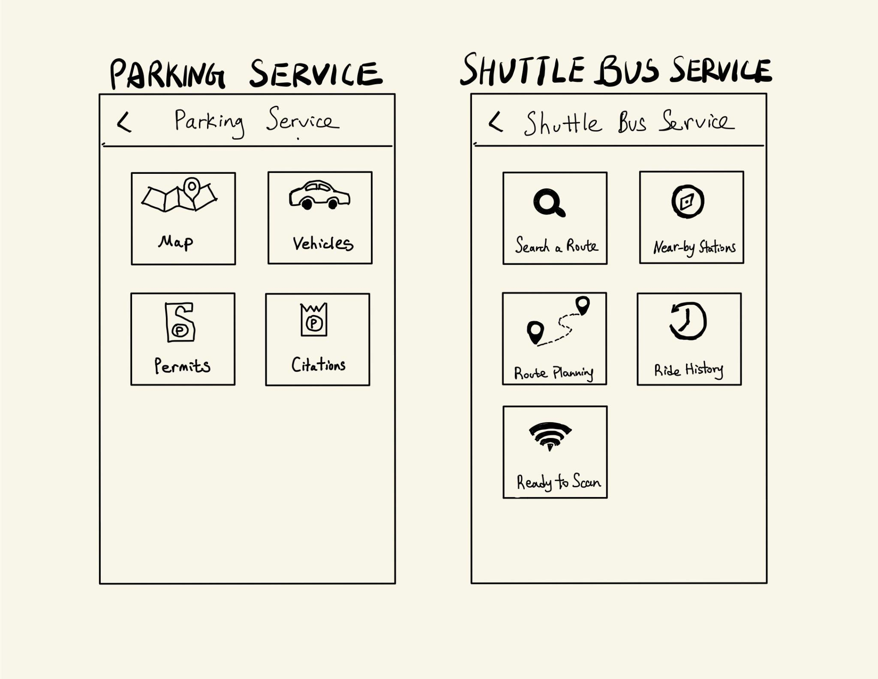

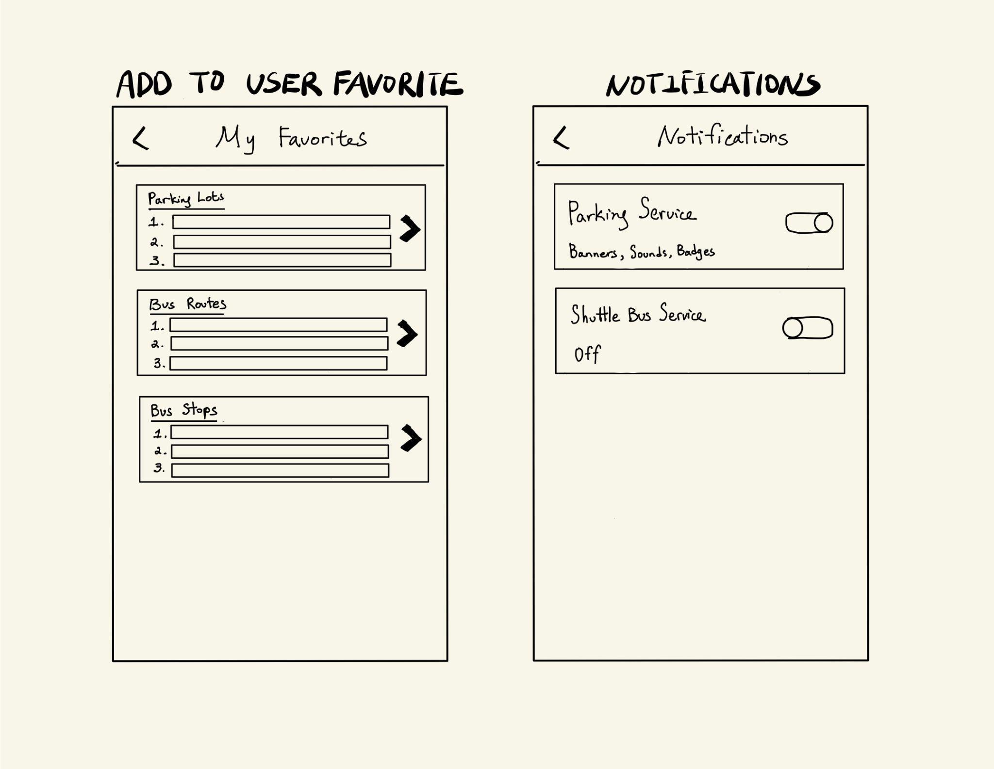

### 

### 

### 9.0 System Design Architecture

For our system we would be opting for Cloud and dedicated hosting architecture.

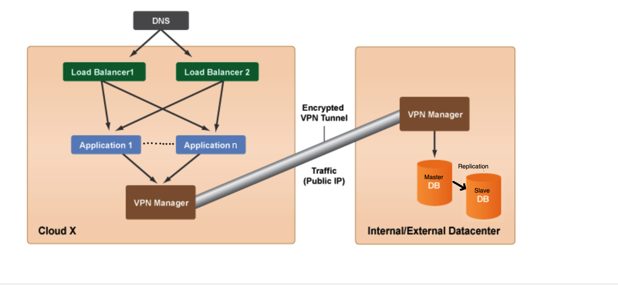

**Architecture:**

1. Users would access the system using the mobile application.
2. The mobile application is connected to the VPC via the internet. Domain Name System Server willresolve the URL for a particular web resource to the TCP-IP address of the system or service which can deliver that resource.
3. A virtual private cloud (VPC) is a secure, isolated private cloud hosted within a public cloud. VPC customers can run code, store data, host applications, and do anything else they could do in an ordinary private cloud, but the private cloud is hosted remotely by a public cloud provider. VPCs combine the scalability and convenience of public cloud computing with the data isolation of private cloud computing.
4. The Load Balancer present in the VPC is used to distribute the network or application traffic across a number of servers. They improve the overall performance of applications by decreasing the burden on servers associated with managing and maintaining application and network sessions, as well as by performing application-specific tasks especially during the peak hour when a large number of users are logging and using the application at the same time.
5. We will also use auto-scaling functionality of the cloud. In case the load on the server increases, for example, during match day the number of people using the application tends to increase, the cloud will have the provision to spin up a new application server to handle the additional workload.
6. The data for students is stored in a private cloud within the VPC as student data is sensitive and it is also legally binding to ensure privacy of students.
7. The datacenter consists of a master node and a slave node. This ensures replication of data and helps in disaster management and data recovery.
8. The cloud and the datacenter interact with each other using an encrypted VPN tunnel.

### 10.0 Testing Plan/Documentation

#### 10.1 Stub Testing

|  |  |  |  |  |  |
| --- | --- | --- | --- | --- | --- |
| Test Name | Test Description | Inputs | Outputs | Expected Results | Potential Errors |
| Check_parking_direction_stub1 | Stubbing recommended parking lot details to check if system shows optimized direction | Login credentials, stubbing for recommended routes | Map is displayed with direction to the chosen parking lot. | Displays the most optimized route to the chosen parking lot. | 1.Route not found 2.Displays unoptimized route |
| Check_notifications_direction_stub2 | Check push notifications by stubbing notification information content. | Login credentials, notification information. | Notifications to be displayed for all users. | Notification information displayed when the app is closed. | Notification doesn't show up if the app is closed, displays only for certain users. |
| Check_account_admin_stub3 | Check access permission for admin, by stubbing information for different kinds of users. | Login credentials for different users | Tickets closed by admin users. | Access to admin users while other users should not have access to closing tickets. | Students and faculty are able to close tickets. |
| Check_nearest_stops_stub4 | Check nearest stops are populated correctly by stubbing bus and route details. | Start and End location, bus and route details. | Display Distance from nearby stops. | Distance from nearby stops is displayed correctly | 1. Distance not displayed correctly  2. Stops from farther distance is displayed instead of nearby stops |
| Check_bus_recommendation_ordering_stub5 | Verify bus recommendations ordered by shortest duration of trip by stubbing route, bus and schedule details | Start and End location, bus and route details | Recommendations are ordered by shortest duration | All Recommendations for nearby stations are ordered by shortest duration of the trip | Trip details of the longest trip are displayed first. |
| Check_bus_recommendation_stub6 | Check bus recommendation by stubbing dynamic display of route and bus details on map | Start and End location, map and bus details. | Recommendations for different buses are displayed. | Recommendation functionality should work fine | 1.Error ‘no route found’  2. Buses for different routes are displayed |
| Check_payment_redirection_stub7 | Stub information from a third-party payment app to check if the redirection to payment app is working fine. | Payment details, otp, address, input from payment app. | Transaction successful. | Page should redirect to payment app and back | 1.Transaction reveals payment details of the user. 2.Transaction not successful in entering the right details. |
| Check_payment_redirection_stub8 | Check nearest parking lots are recommended by stubbing the real time parking lots information | Login details, Location, vehicle details | Nearest available parking lots are displayed | Nearest available parking lots should be displayed to the user. | 1.Unavailable lots are shown as available.  2.Parking lots of farther location is shown when there are other nearby available lots. |
| Check_payment_timeout_stub9 | Check time out when there is no response from gateway or user by stubbing response from payment gateway | Login details, payment details, otp, address, input from payment app, mobile number | Page timeout error is displayed | Page should time out and ask the user to start the process again. | No timeout message and the indefinitely keeps loading. |
| Check_rideHistory_NFC_stub10 | Stub the NFC response to check storing of ride history in the app | User information, nfc response as stub. | Trip information is available in the history of it. | Response from NFC should be stored in the app and the user should be able to view it. | 1.Wrong trip details stored.  2.Error in accepting response from NFC. |

#### 10.2 Unit Testing

|  |  |  |  |  |  |
| --- | --- | --- | --- | --- | --- |
| Test Name | Test Description | Inputs | Outputs | Expected Results | Potential Errors |
| Modify account information_  Unit test1 | Checking modifications of user accounts | Modified user account information | Modification successful | New information displayed in account profile | 1. Unsuccessful modification  2. Invalid inputs  3. New information not displayed in profile |
| Search for a parking lot_  Unit test2 | Checking search for parking lots | Search inputs: user type, arrival time of day, destination | 1. Recommended parking lots based on user inputs  2. Detail information about each recommended parking lots | Parking lots displayed as clickable markers on the interactive map interface | 1. Required field missing  2. Outputs not displayed  3. Inaccurate outputs displayed  4. Users do not turn on location service |
| Add or update vehicle information_  Unit test3 | Checking add vehicle information | Required vehicle information (plate type, plate state, plate number) and optional fields | Successfully add a new vehicle’s information | New vehicle information is added and displayed in the vehicle function | 1. Required field missing  2. Values for the required field are not in the correct format  3. Information not added or displayed in the vehicle list |
| Pay for parking permits_  Unit test4 | Checking pay for parking permits | 1. Permit selection  2. Vehicle to register under the permit  3. Payment method & corresponding payment credential (card holder name, card number, expire date, and code) | 1. Users purchase the selected permit item without error  2. Payment credential approved by third-party online payment system | Users successfully purchased permits and the item is displayed in the permit list function under the parking service module | 1. Selected item does not match with user type  2. Payment is declined by the online payment system  3. Purchased item is not displayed |
| Appeal against citations_  Unit test5 | Checking appeal against citations | 1. Citation number  2. Appeal letter text  3. User personal information (name, contact information, address) | Appeal letter submission confirmation message | User receive a submission confirmation message, submission and status displayed in the citation module | 1. Required fields missing  2. Citation number not found  3. Length of the appeal letter exceeds maximum limit  4. Submission failed  5. Submission not displayed |
| Search for a bus route_  Unit test6 | Checking search for a bus route | Bus route number | 1. Route information based on search inputs  2. Route details (stops and schedule) | Search results are displayed as clickable marker on an interactive map | 1. Invalid route number  2. Results are not displayed on the map  3. Users are not able to interact with the map |
| Search for a nearby bus stop_  Unit test7 | Checking search for nearby bus stops | User location (longitude & latitude) by enabling location service | Nearby bus stops and corresponding detailed stops information | Bus stops displayed as clickable markers on the interactive map | 1. Location service not functioning  2. Users don’t enable location services  3. Search outputs not displayed |
| Plan a route_  Unit test8 | Checking plan a route | 1. User starting location (either manually entered or by enabling location service)  2. Destination (manually entered)  3. Departure and/or arrival time | 1. Available route options sorted by shortest time  2. Nearest route stops from the user starting location and distance  3. Bus arrival time at nearby stops | Search results and corresponding search details displayed as clickable markers or items on the interactive map | 1. Required fields missing  2. Search function unusable  3. Search inputs (time) exceed limitation  4. Search inputs not found  5. Outputs not displayed on the interactive map |
| Opt in push notifications_  Unit test9 | Checking push notification | 1. Notification preference authorization from users  2. Information from parking and shuttle bus service modules | Push notifications containing information from the parking and shuttle bus service modules | Push notifications displayed based on user preference (lock screen, banner, an/or notification center) | 1. Notification not displayed  2. Notifications displayed when user disable the function  3. Inaccurate information |
| Add items to User Favorites_  Unit test10 | Checking add items to User Favorites | Selected items from other modules (bus routes, bus stops, and parking lots) | Selected items successfully added to the User Favorites list | Selected items added to the User Favorites item list and displayed in order | 1. Unable to select items from other modules  2. Selected items not displayed |

#### 10.3 System Testing

|  |  |  |  |  |  |
| --- | --- | --- | --- | --- | --- |
| Test Id | Test Description | Inputs | Outputs | Expected Results | Potential Errors |
| Operating on different system_  System test1 | Applications can launch normally on different operating system (IOS and Android) | System initiated request to open the application | Application initiated and operates successfully | Application runs normally without error | 1. System bugs  2. Outdated operating system  3. Network/server malfunction |
| Send to and receive information from NFC terminals_  System test2 | Users can use the integrated NFC function to send user identification information to the NFC terminals and read and store ride information from terminals | Send user identification by tapping the mobile phone on the NFC terminals on shuttle buses | Bus and ride history information are stored to the shuttle bus service module | Detailed ride information is stored and listed in the ride history function under the shuttle bus service module | 1. NFC terminals are not able to detect user mobile device  2. Inaccurate information is being stored  3. Ride information is not stored at all |
| Log in/out and modify information_System test3 | Users can log into and out of the application and modify personal information | 1. User UMD directory ID and password  2. Edit request | 1. Users log into and out of the application successfully  2. Users have the access to modify personal information | 1. Users are led to the account management module  2. Old information is replaced by the new information | 1. Inaccurate authentication  2. Correct authentication information being entered but application not responding  3. Modified information isn’t stored |
| Shuttle bus service_  System test4 | Users can use the shuttle bus service module to search for shuttle bus route, locate the nearest stop, or plan a route | 1. Bus route number  2. User current location, destination, and planned departure/arrival time | 1. Bus stops for each route  2. Nearest bus stops  3. Optimized travel options | Routes, stops, or travel options are displayed as clickable markers on an interactive map | 1. No result found  2. Users don’t enable location service  3. Entered destination exceeds service range  4. Preferred departure time doesn’t fall within reasonable time range |
| Parking service_  System test5 | Users can use the application to search for parking lots, modify information, pay for permits and citations, and appeal against citations | 1. Preferred destination, user type, and arrival date and time  2. Vehicle information  3. Citation number | 1. Search results (parking lots)  2. New vehicle information  3. Detailed information about purchased permits and citations | 1. Parking lots (search results) are displayed as clickable markers on the interactive map  2. Information listed in each function | 1. Required search fields missing  2. Inaccurate payment information  3. Citation number not found  4. Search results are not displayed on the interactive map  5. Stored data (ex. purchased permits) not displaying |
| Check historical transaction records_  System test6 | Users can check historical transaction records for purchasing permits and paying for citations | User click on the parking service module and select functions accordingly | History payment information (date, item name, payment method, payment amount, and billing address) | Historical payment records are arranged by date and displayed in each function | 1. Missing transaction records  2. Inaccurate transaction information |
| Check favorite items_  System test7 | Users can check and modify item listed in the Add to User Favorites module | 1. System initiated request and edit request  2. New selected items from other modules | Marked items add to the module | The application accurately displayed the marked items in the module | 1. Marked items are not displayed in the module  2. Users are not able to select items from other modules |
| Notification setting_  System test8 | Users can turn on and off the notification setting for different modules and functions | Request to turn on or off a notification setting | Notification setting being turned on or off | Application responses to the request and turn on or off the notification setting without errors | Users are not able to turn on or off a notification setting (application not responding) |
| Peak time performance_System test9 | The application can operate under the high volume of simultaneous users during peak time | Simulate 5000 users login and use application at the same time | 1. system response time  2. error rate  3. throughput – amount of data transmitted per second | Application should be able to run without major breakdown throughout the whole testing period | 1. System response time not meeting business requirements  2. Wrong load-balancing model  3. High probability of errors occurring |
| Online payment security check_  System test10 | Checking if the application will store payment credentials when users are placing an order and completing a transaction | Dummy payment credentials | No new data entries to the cloud database that contains any piece of information about the payment credentials | Card information is not stored in the database | Data is stored automatically without user permission |

#### 10.4 Acceptance Testing

|  |  |  |  |  |  |
| --- | --- | --- | --- | --- | --- |
| Test Id | Test Description | Inputs | Outputs | Expected Results | Potential Errors |
| Account Creation_  Acceptance Test 1 | Check if a new user is created after entering UMD ID, password and verifying user. | UMD ID, Password, Verification code | User account information should be added to the database. | Notification of account created.  Login Page to re-login with the created credentials. | User account not added to database, preventing re-login for the customer |
| User Login_  Acceptance Test 2 | Check if a returning user is able to login into an existing account using correct credentials | UMD ID and password | Successful databases fetches from database for user | User Home page should be displayed upon successful login | 1. Inaccurate authentication  2. Correct authentication information provided but not stored in database |
| Bus Route Details_Acceptance Test 3 | Check if a user is able to see the bus route details of selected route | Bus route number | Query and fetch data regarding the selected bus route | Details of selected bus route should be displayed | 1. Incorrect information is fetched from the database.  2.System taking too long to display the results |
| Bus Stop_  Acceptance Test 4 | Check if a user is able to see the nearest bus stop | 1) Bus route number  2) User location | Select the nearest bus stop for the user based on his current location and given bus route | Nearest bus stop and route to the bus stop from the user's current location should be displayed in a map. | 1. No bus stop found  2. Bus not serving nearest bus stop  3. User location not enabled |
| Search Parking_  Acceptance Test 5 | Check if nearby parking spots available for user are shown upon searching the location | UMD ID, location | Based on users location select all available nearby parking allowed for him | Interactive map displaying all nearby locations for parking to that user with the option to select. | 1.Unable to interact with the map.  2.Map not rendered correctly on screen.  3. Map displaying parking not accessible to user |
| Show Ride History_  Acceptance Test 6 | Check if a user can access their ride history | UMD ID | Query and fetch data about ride history | Display ride history on the basis of UMD ID | 1. User UMD ID not linked to database  2. Incorrect ride history being fetched from database |
| Display Notifications_Acceptance Test 7 | Provide push notifications to the user | Permission of user to enable push notifications | Allow push notifications to be enabled on user’s phone | Display various updates on parking and bus route changes | 1. Notifications not being displayed  2. Inaccurate data being displayed in notifications  3. Blank/test notifications being displayed |
| Payment_ Acceptance Test 8 | Check if the payment made via third party systems on app is successful | Amount, UMD ID, payment details, authorization code | Check if the amount is reflected in the UMD bank account. | Display payment successful notification for successful payment, | 1.Payment successful but amount not reflected in the bank account.  2. Response message  Not being displayed to the user. |
| NFC_Acceptance Test 9 | Check if the ride data is being stored in the database on NFC tap | Tap on NFC terminal using mobile app of user | User information should be stored in the database | Correct Ride info( Bus number, time of boarding, route number) is stored in the database. | 1.Terminal not able to read the NFC via device.  2. Incorrect data getting stored in the database. |
| Parking Info_Acceptance Test 10 | Check if new parking information is added after entering vehicle number and permit number | Vehicle Number, Permit Number | Parking information should be added to the database | Display information added in the user’s account | 1. Information not being stored in database  2. Inaccurate information being retrieved from database  3. Values of required field not in correct format  4. Important fields missing |

#### 10.5 Integration Testing

|  |  |  |  |  |  |
| --- | --- | --- | --- | --- | --- |
| Test Name | Test Description | Inputs | Outputs | Expected Results | Potential Errors |
| Ready to Scan and Track Your Ride_ Integration test1 | Users use the NFC system integrated with the mobile application to send identification information and read ride information from NFC terminals on buses | Identification number of the NFC sensors of the user mobile device and terminals on buses | User information are sent to the NFC terminals and bus/ride information is sent to and stored in the application | User mobile device and the NFC terminals exchange information successfully without an error | 1. User’s mobile device does not send out identification information  2. Users do not turn on the NFC option on mobile device  3. NFC terminals on buses are not working |
| Making online payment_  Integration test2 | Users conduct transactions with third-party online payment systems | Payment credentials (card holder name, card number, expiration date, and SEC code) | 1. Payment acceptance or denial message  2. Receipt/invoice if the payment is accepted | Transactions are approved by the online payment system and the order is successfully placed | 1. Invalid payment credential  2. Payment credential is compromised  3. Account for the payment is with insufficient funds  4. Transactions are submitted but do not go through the payment system  5. Transactions are approved but the users have not been charged |
| Search function with map API_  Integration test3 | Users search for a parking lot based on search inputs and an interactive mapping API process the query and displays the results | Search inputs (user type, starting location, destination, and arrival time of day) | 1. Search results (parking lots) and their corresponding detailed information (name, restrictions, and available spaces)  2. Optimized route to the destination, distance, and travel time | Search results are displayed as interactable markers on the map API | 1. The map API does not receive any information from the search parameters  2. The map API cannot display the search results  3. Users are not able to interact with the map API |
| Cloud-based  application and cloud-  based database_  Integration test4 | Cloud-based mobile application Moving Terps will retrieve data and information from a cloud-based database hosted on a virtual private cloud | 1. Request for data (user to server)  2. Database query (server to database) | 1. Query results in a table format (database to server)  2. Information displayed on the user interface (server to user) | Information/data is displayed on the user interface when users click on each module and with minimized waiting time and without any errors | 1. Server cannot receive request for data from users  2. Server cannot process the request and convert it into a database query  3. Database cannot execute the query and generate results  4. Database cannot return the query results to the server  5. Server cannot process the database response and transmit it to the users |

### 11.0 Implementation Plan

#### 11.1 Objectives

Primary Objective: Successful completion and deployment of the application at mobile end link with UMD DOTS system.

Supporting Objective: Training end users and setting up maintenance rules.

#### 11.2 Details and Deliverables

|  |  |  |  |
| --- | --- | --- | --- |
| **Tasks** | **Deliverables** | **Developed By** | **Approved By** |
| **User Interface -**  Includes interface for students, employers and faculty based on usability. | Deliver interfaces that meet the business needs and all requirements include:   * Create Account View * Create Search History * Create Edit/update information * Create Payment Method * Create Favorites Route * Create Nearby Routes with times to arrive * Create push notifications for whom signed up * Enable users to search the route, nearby station and parking lots * Enable users to track their ride while they are on the shuttle bus | Development Team | System Analyst  Project Manager  Project Sponsor |
| **Integration -**  Includes data and functionality linking between DOTS and integration with supporting NFC terminal. | * Integration with DOTS and NFC system * Integration with students’ enrolled information to check if users are enrolled student at UMD * Integration with UMD staff/ faculty system to check if users are currently hired by UMD * Integration with third-party payment entity to check if the payment methods are fraud | Development Team | System Analyst  Project Manager |
| **Developer/User Documentation -**  Includes all technical documentation delivered during the project; all documentation necessary to effectively operate and maintain the system based on user types | * Provide users with infrastructure setup, daily process information that includes performance assessment * Includes simulations and knowledge-based reports * The software could be run on IOS and Android devices * The software should be used 24/7 * The software should support 5000 simultaneous users from 8-11 am and 3-7 pm; 3000 simultaneous users at all other times | Development Team | System Analyst  Project Manager |
| **Readiness Document -**  Consolidate information regarding the current status of the parking lot and shuttles for users to make Go/No Go decisions. Should include checklists for users preparing to apply for the service. | * Provide information necessary for users to make a decision like which parking lot to park or which shuttles bus to take * Affirm achievement of all deliverable acceptance criteria | System Analyst  Project Manager | Project Sponsor |
| **License Structure -**  Primary contract document between UMD and NFC | * Identity ways that the system can be used by UMD * Ensure NFC’s obligation for UMD’s access and support * Ensure all students with valid UID can access to the account, including creating accounts and submit application * Ensure software won’t store and share any private information of users registered in the system * Personal information should be protected in compliance with the Data Protection Act * Third-party payment system won’t have the right to sell or use users’ payment method for uses other than paying for the parking service for UMD * System should not store user’s credit/ debit card information | System Analyst  Project Manager | Project Sponsor |
| **Post-Implementation review Report-** summarizes the assessment of implementation activities at the end of the implementation phase | * Summarize assessment of implementation activities * Evaluate the effectiveness of the system after the system has been in production * Determine if the system does what it was designed to do * Determine if all users who applied for the parking have received quotation within acceptable time frame with all the information on the citation is correct | System Analyst  Project Manager | Project Sponsor |
| **Standard Operating Procedures -** define in detail on how the system team will perform the business process related to the operations and maintenance of the system. Whereas the User Guide is focused on the use of the system specifically, the SOP addresses all related business processes of our app. | * Provide detailed instructions for future business process * Ensure consistent execution of business process * Drive performance improvement and improve organization results * Provide detailed information on all external entities together building this system with all citations on transaction | Development Team | System Analyst  Project Manager |
| **Training Plan**  -includes full schedule of end-user training for Students and Faculties | Set notification plans to end-users to ensure all system participants can operate systems based on business rules.  - Student Training Plan  - Faculty Training Plan | System Analyst/Project Manager | Project Sponsor |
| **Infrastructure**  -Overall system Performance as intended based on business needs. | - Load Requirements Assessment: Ensure the system can function with full user load.  - Infrastructure Setup-Up Assessment: Ensures process application functionality | Development Team | System Analyst/Project Manager  —  Project Sponsor |
| **Rollout Plan**  -Schedule and methods for actual deployment of MovingTerps for users. | - UMD Faculty Notifications  - UMD Student Notifications  - Deployment Schedule  - Development Response Plan: ensure optimal IT support response for initial rollout. | Project Manager | Project Sponsor |

#### 11.3 Implementation Plan Schedule

|  |  |  |  |
| --- | --- | --- | --- |
| **Task Name** | **Owner** | **Date** | **Status** |
| **Development Activities** |  |  |  |
| Database Design | Development team | 10-May | In Progress |
| Data Migration Plan | Development team | 10-May | In Progress |
| User Interface Design | Development team | 20-May | In Progress |
| Integrations | Development team | 21-Jun | In Progress |
| Reports | System Analyst | 30-Jun | In Progress |
| **Testing Activities** |  |  |  |
| Testing Planning | System Analyst  Project Manager | 30-Jun | In Progress |
| Unit Testing | Development team | 5-Jul | Pending |
| Integration Testing | Development team | 5-Jul | Pending |
| Acceptance Testing | Development team | 8-Jul | Pending |
| **Documentation Prep** |  |  |  |
| Developer Documentation | Development team | 12-Jul | Pending |
| Standard Operating Procedures | System Analyst  Project Manager | 12-Jul | Pending |
| User Documentation | Development team | 12-Jul | Pending |
| **Training** |  |  |  |
| Training Planning | System Analyst | 12-Jul | Pending |
| User Training Development | System Analyst | 12-Jul | Pending |
| User Training Review | System Analyst | 18-Jul | Pending |
| User Training Rollout | Development team | 18-Jul | Pending |
| **Rollout** |  |  |  |
| Architecture Planning | Development team | 19-Jul | Pending |
| Infrastructure Prep | Development team | 19-Jul | Pending |
| License Structure | System Analyst  Project Manager | 19-Jul | Pending |
| Deployment | Development team | 25-Jul | Pending |
| Data Migration Steps | Development team | 25-Jul | Pending |
| User Setup | Development team | 29-Jul | Pending |
| User Training | Development team | 29-Jul | Pending |
| Pilot Rollout Plan/Phase Rollout Plan | System Analyst  Project Manager | 1-Aug | Pending |
| Rollback Steps | Development team | 4-Aug | Pending |
| Readiness Document | System Analyst  Project Manager | 5-Aug | Pending |
| Day 0 Deployment | Development team | 8-Aug | Pending |
| Support Setup | Development team | 8-Aug | Pending |
| Week 1 Support Plan | System Analyst  Project Manager | 15-Aug | Pending |
| Week 1 Daily Review Meeting | Development team | 15-Aug | Pending |
| Post Implementation Review Report | System Analyst  Project Manager | 19-Aug | Pending |

### 12.0 Conclusion

The requirements are collected through interviewing a wide range of actual users of the service provided by the DOTS. Interviews are also conducted on the system administrators to recognize the flaws of the current system. User feedback is the fundamental component of designing our mobile application and all perspectives are being considered in order to meet the business requirements set. Further integrations with systems like third-party vehicle or bike rental systems can be performed once the mobile application is successfully implemented and the operation of the application is proven to be up to standard and approved by the users.

## Appendix - Feedback from Previous Submissions

*1.0 Feedback from Submission 1*

* System must be able to filter search results based on user types/search inputs
* System must allow users to sign up push notifications

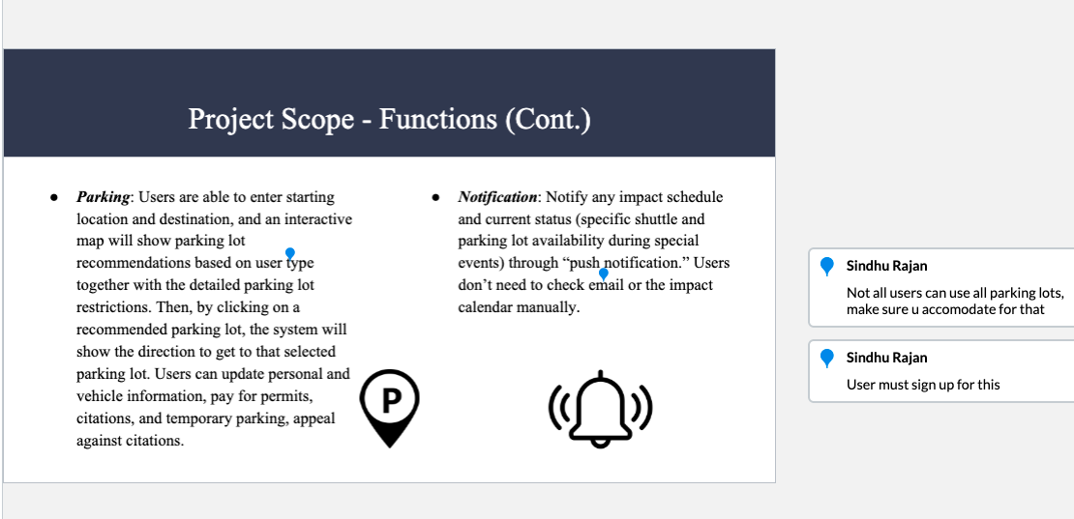

*2.0 Feedback from Submission 2*

* Add primary keys, foreign keys, and fields to the entity relationship diagram (ERD) to convert it into a physical entity relationship diagram (physical ERD.)
* Should keep the same id name across different tables (ex. usrUID)

